Sample Assessment Tasks

Computer Science

General Year 11

Copyright
© School Curriculum and Standards Authority, 2014
This document – apart from any third party copyright material contained in it – may be freely copied, or communicated on an intranet, for non-commercial purposes in educational institutions, provided that the School Curriculum and Standards Authority is acknowledged as the copyright owner, and that the Authority’s moral rights are not infringed.
Copying or communication for any other purpose can be done only within the terms of the Copyright Act 1968 or with prior written permission of the School Curriculum and Standards Authority. Copying or communication of any third party copyright material can be done only within the terms of the Copyright Act 1968 or with permission of the copyright owners.
Any content in this document that has been derived from the Australian Curriculum may be used under the terms of the Creative Commons Attribution-NonCommercial 3.0 Australia licence
Disclaimer
Any resources such as texts, websites and so on that may be referred to in this document are provided as examples of resources that teachers can use to support their learning programs. Their inclusion does not imply that they are mandatory or that they are the only resources relevant to the course.

Sample assessment task

Computer Science – General Year 11

Task 5 – Unit 1 – Managing data
Assessment type: Theory test

Conditions
Time for the task: One period in class

Task weighting
5% of the school mark for this pair of units
__________________________________________________________________________________

- a) List four (4) techniques used to ensure that data stored on a personal computer can be easily accessed. (4 marks)
Technique 1: ________________________________________________________________
Technique 2:________________________________________________________________
Technique 3: ________________________________________________________________
Technique 4: ________________________________________________________________

b) Describe how you could use one (1) of the listed data management techniques.
(2 marks)
__________________________________________________________________________
__________________________________________________________________________
__________________________________________________________________________

Question 2 relates to the following screen capture of a database table.
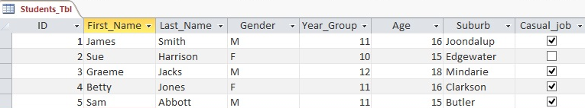
- a) Identify the number of records that are in the database table. (1 mark)
__________________________________________________________________________

b) Identify the number of fields that are in the database table. (1 mark)
__________________________________________________________________________

c) Identify the data type for the Casual_job field. (1 mark)
__________________________________________________________________________

- Identify the type of database object represented in the following screen capture. (1 mark)
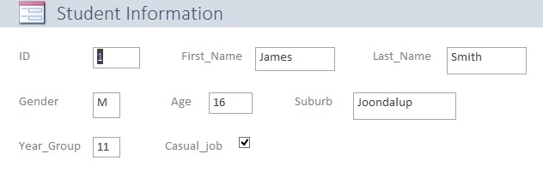

__________________________________________________________________________

Question 4 relates to the following screen capture from a spreadsheet.
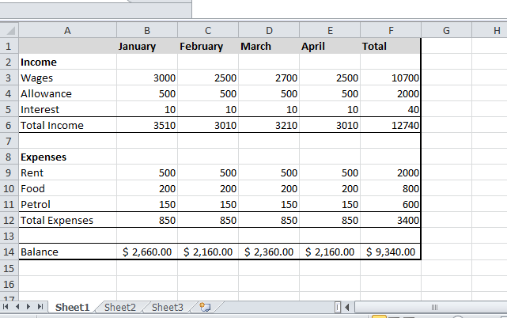

- a) The cell F3 contains the value for total wages for the period January to April. Provide the spreadsheet function for cell F3 to calculate the total wages for the period January to April. (4 marks)
__________________________________________________________________________

- The cell B12 contains the total expenses for January. Provide the spreadsheet function for cell B12 to calculate the total expenses for the month of January. (4 marks)
__________________________________________________________________________

- The cell B14 contains the balance available for the month of January. Provide the spread sheet formula to determine balance for January. (3 marks)
__________________________________________________________________________

- Identify the data type for the following cells: (3 marks)
B14: ____________________________________________________
A12: ____________________________________________________
E5: ____________________________________________________

Question 5 relates to the following table of data from a database.

Country Name | Country Area (SqKm) | Population | Capital City | Continent | Government
Zambia | 753,000 | 10,000,000 | Lusaka | Africa | Republic
Brazil | 8,511,965 | 184,101,019 | Brasilia | South America | Federative republic
Australia | 7,686,850 | 19,913,114 | Canberra | Australia | Democratic, federal-state
China | 9,596,960 | 1,298,847,624 | Beijing | Asia | Communist state
Norway | 324,220 | 4,574,560 | Oslo | Europe | Constitutional monarchy

- a) Identify the data type most suitable for each of the following fields: (2 marks)
Population field: __________________________________________
Government field:_________________________________________
- Create a simple query that will provide a list of countries with a population greater than 1,000,000 people. (3 marks)
__________________________________________________________________________

- Create a simple query that will provide a list of countries located in Europe. (3 marks)
__________________________________________________________________________

Total = 32 marks

ACKNOWLEDGEMENTS
Screenshots used with permission from Microsoft.

Marking key for sample assessment task 5 – Unit 1
- a) List four (4) techniques used to ensure that data stored on a personal computer can be easily accessed.
Description | Marks
Correctly lists the data management techniques | 1–4  (1 mark each)
Answer could include, but is not limited to:
- consistent use of files and folders
- consistent file naming conventions
- use of date and/or time
- avoidance of file duplication

b) Describe how you could use one (1) of the listed data management techniques.
Description | Marks
Provides a description of the function of one of these techniques | 2
Provides a limited description of the function of one of these techniques | 1

- a) Identify the number of records that are in the database table.
Description | Marks
Correctly identifies the number of fields | 1
Answer
5

b) Identify the number of fields that are in the database table.
Description | Marks
Correctly identifies the number of records | 1
Answer
7

c) Identify the data type for the Casual_job field.
Description | Marks
Correctly identifies the data type | 1
Answer
Boolean

- Identify the type of database object represented in the following screen capture.
Description | Marks
Correctly identifies the type of database object | 1
Answer
Form

- a) The cell F3 contains the value for total wages for the period January to April. Provide the spreadsheet function for cell F3 to calculate the total wages for the period January to April.
Description | Marks
Provides the correct spreadsheet function which  - starts with an equal sign  - includes the function SUM  - includes the correct cell range (with a colon or comma)  - encloses range in brackets | 1  1  1  1
Total | 4
Answer
=SUM(B4:E4)
Answer may vary depending on version and/or type of spreadsheet software.

- The cell B12 contains the total expenses for January. Provide the spreadsheet function, in cell B12 to calculate the total expenses for January.
Description | Marks
Provides the correct spreadsheet function which  - starts with an equal sign  - includes the function SUM  - includes the correct cell range (with a colon or comma)  - encloses range in brackets | 1  1  1  1
Total | 4
Answer
= SUM(B9:D11)
Answer may vary depending on version and/or type of spreadsheet software.

- The cell B14 contains the balance available for the month of January. Provide the spreadsheet formula to determine balance for January.
Description | Marks
Provides the correct spreadsheet formula which  - starts with an equal sign  - includes the cell B6 and B10  - includes the minus (-) operator | 1  1  1
Total | 3
Answer
=B6-B12
Answer may vary depending on version and/or type of spreadsheet software.

- Identify the data type for the following fields:
B14; A12; E5
Description | Marks
Identifies the correct data type | 1–3  (1 mark for each data type)
Answer
B14: Currency
A12: Text
E5: Number
- a) Identifies the data type most suitable for the:
Population field
Government field
Description | Marks
Identifies the correct data type | 1–2  (1 mark for each data type)
Answer
Population field: Number
Government field: Text

b) Create a simple query that will provide a list of countries with a population greater than 1,000,000 people.
Provides the correct query which includes the following elements:  - Population  - A greater than sign  - 1,000,000 | 1–3  (1 mark for each element)
Answer
Population > 1,000,000

- Create a simple query that will provide a list of countries located in Europe.
Description | Marks
Provides the correct query which includes the following elements:  - Continent  - An equals sign  - Europe | 1–3  (1 mark for each element)
Answer
Continent = Europe

Sample assessment task

Computer Science – General Year 11

Task 4 – Unit 1 – Spreadsheets
Assessment type: Practical test

Conditions
Time for the task: 50 minutes

Task weighting
4% of the school mark for this pair of units.
_________________________________________________________________________________

The screen capture below provides the data you are to use for this test.

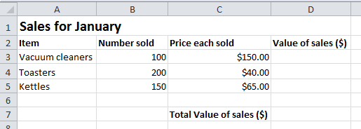

Create a spreadsheet file, and save the file with the file name CSCspreadsheet_test _yourname.
At the end of this test you are required to submit a digital copy of the finished spreadsheet via email to your teacher.

- Enter into your spreadsheet the data as shown in the screen capture above. Ensure that you enter all text and data into the same cells as shown. (4 marks)

- Apply the following formatting to the spreadsheet:
- centre alignment to cells B2, C2, D2 and C7 (4 marks)
- bold the text in cells A1 and C7 (2 marks)
- decimal formatting to cells C3, C4 and C5 (3 marks)
- borders around each cell from A2 to D7 (1 mark)
- Apply the following formatting to the spreadsheet:
- merge and centre the heading for the spreadsheet between cells A1 and D1 (1 mark)
- increase the font size of the heading to 18 points (1 mark)
- change the font typeface to a different font from the default one on the
computer you are using. (1 mark)

- Create a formula in cell D3 that will multiply the number of vacuum cleaners sold in January by the price of each vacuum cleaner. (3 marks)

- Copy the formula in cell D3 into cells D4 and D5. (2 marks)

- Create a function in cell D7 that will add the value of sales for the three items to obtain the total value of sales for January. (4 marks)

- Create a pie chart showing the number sold for each item and include the item name in the legend. Your pie chart should look like the one below. (3 marks)
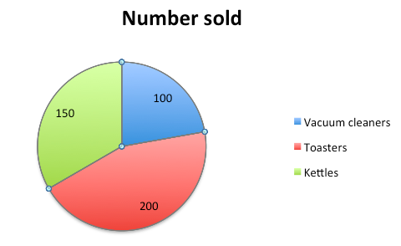

- a) Copy all the data to a new sheet in your spreadsheet: (2 marks)

b) Rename the original spreadsheet sheet with the name ‘Original SS’ and rename the second spreadsheet sheet with the name ‘sorted SS’. (2 marks)

The tabs on your spreadsheet should look like those shown below.
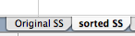
c) In the ‘sort SS’ sheet, sort the table of data so that the value of sales figures is in ascending order. Your answer should look the same as the following screenshot.
(2 marks)
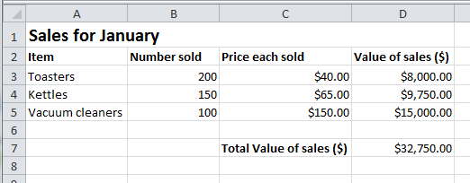
Total = 35 marks

ACKNOWLEDGEMENTS
Screenshots used with permission from Microsoft.

Marking key for sample assessment task 4 – Unit 1

- Enter into your spreadsheet the data as shown in the screen capture above. Ensure that you enter all text and data into the same cells as shown.
Description | Marks
All text and numbers are entered into the correct cells  Some of the text and numbers are entered into the correct cells | 2  1
Subtotal | 2
The spelling of text is the same as the example | 1
The numbers are entered correctly | 1
Subtotal | 2
Total | 4

- Apply the following formatting to the spreadsheet:
  - centre alignment to cells B2, C2, D2 and C7
Description | Marks
Text is centre aligned in each of the required cells | 1–4  (1 mark each)
  - bold the text in cells A1 and C7
Description | Marks
Text in each cell is bold | 1–2  (1 mark each)
  - decimal formatting to cells C3, C4 and C5
Description | Marks
The number in each cell has been formatted to decimal | 1–3  (1 mark each)
  - borders around each cell from A2 to D7.
Description | Marks
A border is created for the cell range A2 to D7 | 1

- Apply the following formatting to the spreadsheet:
  - merge and centre the heading for the spreadsheet between cells A1 and D1
Description | Marks
The heading has been correctly merged and centred | 1
  - increase the font size of the heading to 18 points
Description | Marks
The heading has been correctly changed | 1
  - change the font typeface to a different font from the default one on the computer you are using.
Description | Marks
The default font typeface has been correctly changed to another font | 1
- Create a formula in cell D3 that will multiply the number of vacuum cleaners sold in January by the price of each vacuum cleaner.
Description | Marks
Provides the correct spreadsheet formula which:  - starts with a =  - includes the cells B3 and C3  - includes the operator * | 1  1  1
Total | 3
Answer
=B3*C3

- Copy the formula in cell D3 into cells D4 and D5.
Description | Marks
Correctly copies the formula in cell D3 to cell D4 | 1
Correctly copies the formula in D3 to D5 | 1
Total | 2
Answer
The formula in cell D4 should read =B4*C4
The formula in cell D5 should read =B5*C5
Note: If SUM was included in cell D3 and this error is copied into cells D4 and D5, the mark should be awarded, as this question is testing whether students can copy a formula from one cell to another cell.

- Create a function in cell D7 that will add the value of sales for the three items to obtain the total value of sales for January.
Description | Marks
Provides the correct spreadsheet function which:  - starts with an equal sign  - includes the function SUM  - includes the correct range of cells (with a comma or a colon)  - encloses range in brackets | 1  1  1  1
Total | 4
Answer
=SUM(D3:D5)
Note: Answer may vary depending upon the type of spreadsheet program available

- Create a pie chart showing the number sold for each item and the item name in the legend.
Description | Marks
Creates the pie chart | 1–3
Answer
The pie chart should include:
- an accurate legend
- a title
- display the number sold for each item

- a) Copy all the data to a new sheet in your spreadsheet
Description | Marks
Correctly copies the data to the second sheet | 1
Original format is maintained | 1
Total | 2
b) Rename the original spreadsheet sheet with the name ‘Original SS’ and the second spreadsheet sheet with the name ‘sorted SS’.
Description | Marks
Correctly renames the original sheet and the new sheet | 1–2
c) In the ‘sorted SS’ sheet, sort the table of data so that the value of sales figures is in ascending order. Your answer should look the same as the following screenshot.
Description | Marks
Correctly sorts all columns based on the value of sales data | 2
Correctly sorts the value of sales column from lowest to highest | 1

Sample assessment task

Computer Science – General Year 11

Task 9 – Unit 2 – Game creation
Assessment type: Project

Conditions
Period allowed for completion of the task: 3 weeks

Task weighting
15% of the school mark for this pair of units
__________________________________________________________________________________
Scenario
One of the earliest computer games developed was ‘Pong’. The game required two players to hit a ball with a bat, back and forth across the screen, until one player missed the ball.
The original screen for Pong was similar to the one below.
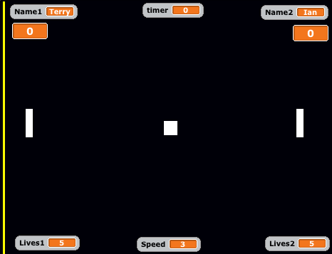

Your task is to create a new version of the Pong game, using a programming environment, such as Scratch.
Your version of the game should apply the following rules or conditions:
- allow two people to play against each other, with a bat on each side of the screen that can move up and down
- the left side bat should be operated using the ‘A’ and ‘Z’ keys
- the right hand bat should be operated using the ‘K’ and ‘M’ keys
- keep a score for each player
- the game ends when either player misses the ball five (5) times
- the ball should increase speed slightly as the game continues
- include sounds and/or music
Journal (8 marks)
Create a time plan that will ensure that you can complete the planning, creation and evaluation of your game within the three (3) weeks provided. For each class, identify what you do achieve and why you did or did not achieve your target.

Date / Period number | What I need to achieve in this class | What I did achieve in this class | Why I did or did not achieve my target(s)

Part 1 – Programming considerations (15 marks)
Create an IPO chart for your computer game, indicating the inputs, processes and outputs for your game.

For example:
Input
- The user inputs to the program, for example:
  - Player 1 name
Processes
- Processes that will occur while the program is running, for example:
  - left bat moves 30 points up when the user presses the A key
- Variables that will change during the program, for example:
  - the number of lives will decease when the player misses a ball
Outputs
- Feedback that the user will receive at the start, during and at the end of the program,
for example:
  - sound when the ball hits or misses a bat

Inputs | Processes | Outputs

(9 marks)

Create a plan for your computer game, outlining how each of the following components will be included in the program for your computer game
- sound and music (e.g. when the ball hits or misses a bat)
- special effects (e.g. speed of ball increases as game time increases)
- images (e.g. use of sprites)
- variables (e.g. player name)
- control structures (selection and iteration) (6 marks)
Part 2 – Product development (35 marks)
Create your computer game, using a programming environment, such as Scratch. Make sure that you refer to your time plan, the IPO chart and all of the components of your plan for your computer game.
Your computer game will be assessed on:
- use of sound and music (4 marks)
- use of special effects (4 marks)
- use of original images (4 marks)
- use of variables (3 marks)
- use of the selection control structure (6 marks)
- use of iteration control structure (6 marks)
- whether the game is complete, functional, without syntactic and logical errors and well-designed
(8 marks)

Part 3 – Evaluation (8 marks)
Once you have finished creating your computer game, you need to evaluate its effectiveness and identify how your game could be improved. To do this, answer the following questions:
- How does your computer game match your IPO chart? (2 marks)
- How effective is your computer game as a software solution? (3 marks)
- How would you improve the process that you followed to develop your computer game?
(3 marks)

Total = 66 marks

ACKNOWLEDGEMENTS
Pong screen shot created in Scratch (http://scratch.mit.edu/)
Used under Creative Commons Attribution-ShareAlike 2.0 Generic licence. Scratch is developed by the Lifelong Kindergarten Group at the MIT Media Lab.
Marking key for sample assessment task – Unit 2

Description |  | Marks
Journal
Creates and maintains a time plan that allows for potential interruptions, with realistic achievement targets, providing appropriate achievement statements for each of the planning, development and evaluation phases of the game. |  | 7–8
Creates and maintains a time plan, with realistic achievement targets, providing appropriate achievement statements for each of the planning, development and evaluation phases of the game |  | 5–6
Creates and maintains a time plan, with incomplete achievement statements for each the planning, development and evaluation phases of the game |  | 3–4
Creates and partly maintains a time plan, providing incomplete achievement statements for the planning, development and evaluation phases of the game. |  | 1–2
Total for Journal |  | 8
Part 1 – Programming considerations
IPO chart
Correctly identifies at least three appropriate:  - inputs  - processes  - outputs |  | 1–3  1–3  1–3
Subtotal |  | 9
Plan for the computer game outlines how each of the components will be incorporated:  - sound and music (1)  - special effects (1)  - images (1)  - variables (1)  - control structures (selection and iteration) (2) |  | 1–6
Subtotal |  | 6
Total for Part 1 – Programming considerations |  | 15
Part 2 – Product development
Appropriate use of sound and music |  | 1–4
Appropriate use of special effects |  | 1–4
Appropriate use of original images |  | 1–4
Subtotal |  | 12
Use of variables
- correctly applies a range of variable types with relevant names  - uses a range of variables  - limited use of variables |  | 3  2  1
Subtotal |  | 3
Use of the selection control structure
- demonstrates an appropriate use of a range of selection control structures throughout the program  - demonstrates an appropriate use of a limited range of selection control structures throughout the program  - demonstrates limited and inappropriate use of selection control structures throughout the program |  | 5–6  3–4  1–2
Subtotal |  | 6
Use of iteration control structure
- demonstrates an appropriate use of a range of control structures throughout the program  - demonstrates an appropriate use of a limited range of control structures throughout the program  - demonstrates an limited and inappropriate use of control structures throughout the program |  | 5–6  3–4  1–2
Subtotal |  | 6
Part 2 – Product development
Completeness and functionality of game
The game is  - complete, functional, without syntactic and logical errors and well-designed  - partially complete, functional, without syntactic and logical errors and well-designed  - partially complete, functional, with syntactic and logical errors and poorly designed  - partially complete, non-functional and poorly designed | 7–8  5–6  3–4  1–2
Subtotal | 8
Total for Part 2 – Product development | 35
Part 3 – Evaluation
Matching the IPO chart
Provides a statement identifying how the final product matches the IPO chart | 1–2
Effectiveness of completed game as a software solution
Provides an appropriate explanation of the effectiveness of the game as a software solution | 1–3
Program improvements
Provides an appropriate description of potential improvements to the process used to develop the game | 1–3
Total for Part 3 – Evaluation | 8

Total for Journal | 8
Total for Part 1 – Programming considerations | 15
Total for Part 2 – Product development | 35
Total for Part 3 – Evaluation | 8
Task Total | 66

