Sample Assessment Tasks

Italian: Second Language

ATAR Year 12

Copyright
© School Curriculum and Standards Authority, 2015
This document – apart from any third party copyright material contained in it – may be freely copied, or communicated on an intranet, for non-commercial purposes in educational institutions, provided that the School Curriculum and Standards Authority is acknowledged as the copyright owner, and that the Authority’s moral rights are not infringed.
Copying or communication for any other purpose can be done only within the terms of the Copyright Act 1968 or with prior written permission of the School Curriculum and Standards Authority. Copying or communication of any third party copyright material can be done only within the terms of the Copyright Act 1968 or with permission of the copyright owners.
Any content in this document that has been derived from the Australian Curriculum may be used under the terms of the Creative Commons Attribution-NonCommercial 3.0 Australia licence
Disclaimer
Any resources such as texts, websites and so on that may be referred to in this document are provided as examples of resources that teachers can use to support their learning programs. Their inclusion does not imply that they are mandatory or that they are the only resources relevant to the course.

Sample assessment task

Italian: Second Language – ATAR Year 12

Task 2 – Unit 3
Assessment type: Oral communication

Conditions

Time for the task: 20 minutes preparation, 5–6 minute discussion

A bilingual Italian/English print dictionary can be used for this task.

Task weighting

4.5% of the school mark for this pair of units
__________________________________________________________________________________

Cose italiane (25 marks)

You will participate in a 5–6-minute discussion with your teacher based on Cose italiane in your life. You may use one ‘prop’ (an artefact or a photograph related to Cose italiane) during the discussion.

In the lesson prior to your scheduled discussion, you will be given the opportunity to:
- discuss and make notes on the topic (using the planning sheet provided)
- practise asking and responding to questions with a partner.
In preparation for your discussion, consider the following questions related to ‘The individual: Cose italiane’.
- Perché hai deciso di studiare italiano?
- (Relating to the prop) Cosa hai portato? Quale significato ha per te? / Quale oggetto o fotografia hai portato e perché?
- Quali sono le cose italiane di cui sei appassionato/a?
- In che modo l’Italia ti ha influenzato?
- Nel quartiere dove abiti l’influenza della cultura italiana è molto visibile e sentita?
- Qual è il tuo cibo italiano preferito?
- Hai mai preparato un piatto italiano? Quale?
- Come studente di lingua italiana quali sono gli aspetti della lingua o della cultura italiana che hai condiviso con la tua famiglia o con i tuoi amici?
- Secondo te lo stile di vita dei giovani australiani è diverso dallo stile di vita dei giovani italiani?
- Parla di una cosa italiana che ti piacerebbe avere/provare/vedere.

These questions are only a guide to what you may be asked during the discussion. Depending on your responses, you may be asked variations of these questions or other questions related to the topic.

Planning sheet
Perché hai deciso di studiare italiano?

Cosa hai portato? Quale significato ha per te?
Nel quartiere dove abiti l’influenza della cultura italiana è molto visibile e sentita?

In che modo l’Italia ti ha influenzato?
Parla di una cosa italiana che ti piacerebbe avere/provare/vedere.

Marking key for sample assessment task 2 – Unit 3
Description | Marks
Comprehension | /4
Comprehends all questions and comments (simple and complex) with no or minimal need for clarification | 4
Comprehends most questions and comments (simple and complex) with some need for clarification and/or repetition | 3
Occasionally hesitates, but comprehends most simple and well-practised questions.  Has difficulty when processing complex questions, even after repetition or rewording | 2
Shows limited evidence of comprehension, resulting in numerous silences, even after frequent repetition and rewording | 1
Does not show any evidence of comprehension | 0
Response (relevance and depth of information) | /6
Responds, informs and engages with breadth and depth, providing original opinions, ideas and a wide range of information related to questions and comments made by the marker | 6
Responds and informs with opinions, ideas and a good range of information related to questions and comments made by the marker | 5
Responds with relevant ideas and a range of information related to questions and comments made by the marker | 4
Responds with adequate information related to questions and comments made by the marker | 3
Responds with a limited range of information related to questions and comments made by the marker | 2
Responds with very limited or frequently irrelevant information to questions and comments made by the marker | 1
Does not respond to questions and comments made by the marker or responds in another language | 0
Language range (vocabulary and grammar) | /5
Uses a breadth and sophistication of vocabulary, grammar and sentence structure | 5
Uses a good range of vocabulary, grammar and sentence structure | 4
Uses a satisfactory range of vocabulary and grammar, relying predominantly on simple sentence structure | 3
Uses set structures and basic vocabulary with repetition, relying on non-Italian sentence structures and vocabulary | 2
Uses single words and short phrases | 1
Shows no evidence of a range of vocabulary, grammar and sentence structures | 0
Language accuracy (grammar) | /6
Applies rules of grammar with a very high level of accuracy and consistency, e.g. (where applicable) present, future, past tenses; present conditional mood; adjectives; conjunctions; adverbs | 6
Applies rules of grammar with a high level of accuracy and consistency | 5
Applies rules of grammar with a good level of accuracy and consistency | 4
Applies rules of grammar with a satisfactory level of accuracy and reasonable consistency | 3
Applies rules of grammar with inaccuracies and often inconsistently | 2
Shows inconsistent application of rules of grammar | 1
Shows no application of rules of grammar | 0
Speech (flow, pronunciation and intonation) | /4
Pronunciation is consistently clear and comprehensible, with varied intonation  Speaks spontaneously and naturally and, where ‘think time’ is required, uses appropriate ‘fillers’ | 4
Pronunciation is highly comprehensible. Intonation is sometimes varied  Speaks with some spontaneity, but ‘think time’ may be required | 3
Pronunciation is acceptable. Intonation shows little variation  Some hesitation and/or repetition is evident | 2
Pronunciation is unclear and inaccurate  Frequent hesitation and/or pauses occur | 1
Does not apply the rules of pronunciation and intonation | 0
Total | /25

Sample assessment task

Italian: Second Language – ATAR Year 12

Task 3 – Unit 3
Assessment type: Response: Viewing and reading

Conditions

Time for the task: 40 minutes in class under test conditions

A bilingual Italian/English print dictionary can be used for this task.

Task weighting

3.5% of the school mark for this pair of units
__________________________________________________________________________________

Il Made in Italy nel mondo (35 marks)
Read the three texts and answer the questions in English.

Text 1 – Description (13 marks)
Gli Italiani all’estero: la nuova serie con Ivan Santi
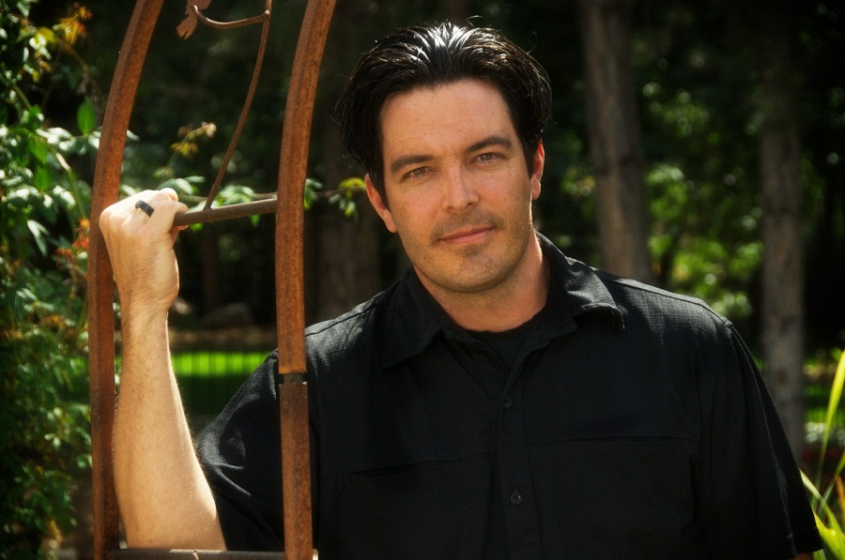
Dopo più di due anni di assenza, Ivan Santi torna sul piccolo schermo con questo nuovo programma.
Il programma affronta in ogni puntata un paese diverso che ha visto una grande immigrazione d’italiani e discute se hanno avuto impatto culturale, sociale, economico o politico sul paese.
La prima puntata debutta il 20 aprile con ‘Gli Italiani all’estero: Australia’.
Sinopsi
In Australia, su circa 20 milioni di abitanti, oltre un milione è di origine italiana, senza contare la seconda e la terza generazioni. La nazione australiana, d'altronde, è nata in seguito alle ondate migratorie arrivate da tutto il mondo.
Ma quanto conta il contributo italiano nella storia di questo paese?
Scopriamo le storie di molti italo-australiani e vediamo come la fantasia e il coraggio usati da molti dei nostri connazionali per cominciare nuove attività, hanno senz'altro influito nella formazione della cultura australiana. Numerose famiglie italiane che hanno lasciato la propria impronta nella storia e nella cultura australiana, hanno mescolato la propria tradizione e le proprie competenze con quello che il nuovo mondo ha offerto. e continua a rappresentare per loro.
Visitiamo la città di Fremantle dove, nel primo decennio del 1900 pescatori siciliani e pugliesi hanno stabilito una “Società di pesca”, una cooperativa per la vendita del pesce. E dove i discendenti di questi primi pescatori continuano a figurare oggi nella cooperativa “Fremantle”. A Melbourne vediamo l’impatto italiano nel campo agricolo, industriale e nel settore della ristorazione. Ed a Ingham, nel nord del Queensland, dove si coltiva la canna da zucchero e dove ogni anno viene celebrata la Festa degli Australiani e Italiani.

1. What is Italiani all’estero? (2 marks)
______________________________________________________________________________
______________________________________________________________________________

2. What do you know about the man in the photograph? (3 marks)
______________________________________________________________________________
______________________________________________________________________________
______________________________________________________________________________

3. What comment is made about the birth of the Australian nation? (3 marks)
______________________________________________________________________________
______________________________________________________________________________
______________________________________________________________________________

4. Complete the following sentence. (2 marks)
According to the article, Italians are now clearly part of the Australian story and culture because they __________________________________________________________________
______________________________________________________________________________

5. What happened in Fremantle at the beginning of the 1900s? (2 marks)
______________________________________________________________________________
______________________________________________________________________________

6. Why is Ingham associated with Italians? (1 mark)
______________________________________________________________________________

Text 2 – Article (12 marks)
Il Made in Italy all’estero
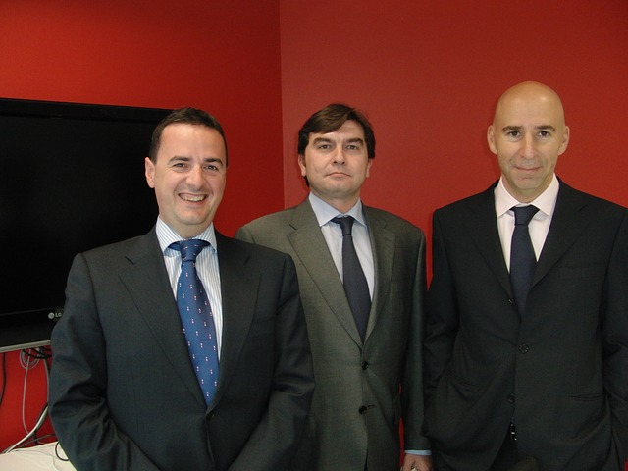
di Giovanna Lamberti
È arrivata nel linguaggio del business una nuova espressione – Italian Sounding. È usata per descrivere un prodotto estero con un nome italiano o che presenta sulla confezione un’immagine sinonima dell’Italia (per esempio il Tricolore) ma non è prodotto in Italia. Al consumatore sembra di comprare un prodotto autentico Made in Italy ma così non è.
I leader del consorzio ‘Niente Italian Sounding’ si sono riuniti ieri in preparazione per l’incontro lunedì con il viceministro Sprecchi.
I principali colpevoli sono l'Australia, la Nuova Zelanda,
gli Stati Uniti e la Cina. In Cina il falso Made in Italy è arrivato perfino prima di quello originale!
Lunedì prossimo a Roma si incontreranno i leader del consorzio ‘Niente Italian Sounding’ e
il viceministro degli Affari Esteri. Lo scopo dell’incontro sarà di avviare una campagna di collaborazione con i governi dei paesi dove l’Italian Sounding è più diffuso per controllare l’abuso del marchio Made in Italy.
7. Describe the significance of the borrowed English phrase ‘Italian sounding’. (2 marks)
______________________________________________________________________________
______________________________________________________________________________
8. Why does the journalist mention Australia, the United States and New Zealand? (2 marks)
______________________________________________________________________________
______________________________________________________________________________
9. What does the journalist say about China? (2 marks)
______________________________________________________________________________
______________________________________________________________________________
10. What happened yesterday? (3 marks)
______________________________________________________________________________
______________________________________________________________________________
______________________________________________________________________________
11. Explain the goal of the meeting to be held in Rome. (3 marks)
______________________________________________________________________________
______________________________________________________________________________

______________________________________________________________________________
Text 3 – Blog posting (10 marks)

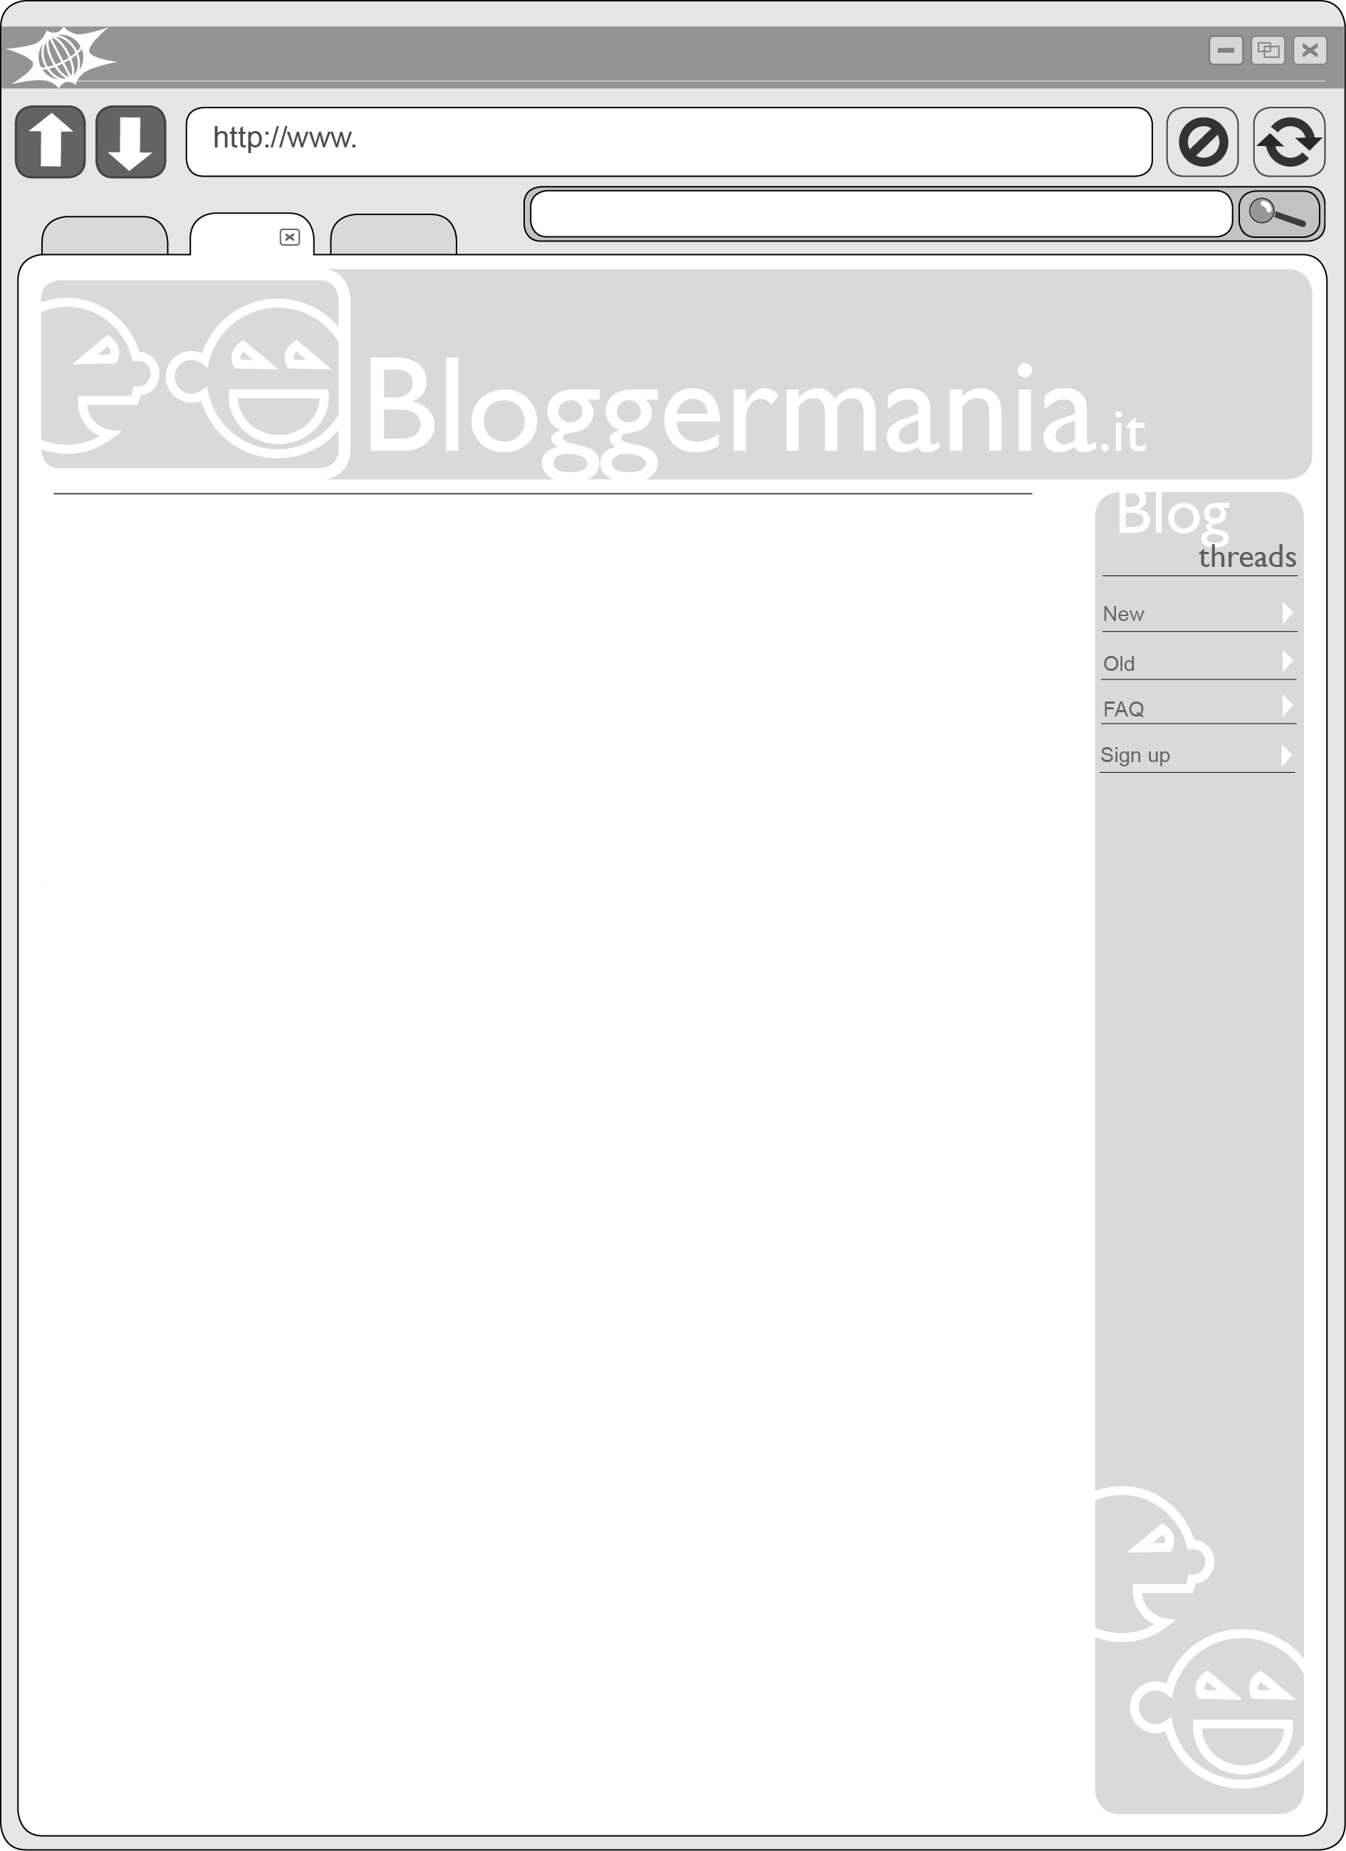
‘Made in Italy’ o no…?
Sembra Italiano vero...ma lo è? In Canada stanno facendo una campagna per educare la gente sui prodotti ‘Made in Italy’ e quelli che sembrano italiani ma non lo sono. Non è neppure limitata ai negozi, hanno creato anche un hashtag su Instagram; così coinvolgono anche i giovani e la nuova generazione di consumatori. È una buona idea secondo voi?
Migliore risposta
Pasqualino
Sì!! Per me è importante che il mondo capsica bene cosa vuol dire ‘Made in Italy’. È la nostra cultura, non solo un prodotto o un marchio. I prodotti falsi, che sembrano italiani, non sono della stessa qualità e non sono autentici. Quanti esempi si potrebbero fare!!
Commenti (6)
Altre risposte
Zero07
Bravi con l’idea del hashtag! Dobbiamo tutti usare questo strumento per speigare al mondo l’importanza di conoscere i veri prodotti Made in Italy!
Anche qui in Italia si sta intensificando la riconquista del nostro brand. Sulla scia della notizia di una crescita della richiesta di prodotti italiani nei mercati internazionali (India, Russia e Emirati Arabi hanno mostrato la crescita più significativa!) è stato lanciato ieri un nuovo progetto dell’impresa no-profit Commercio-Italia sviluppato insieme al governo italiano. Sono in offerta 102 borse di studio a giovani italiani che - se selezionati - aiuteranno le imprese italiane a sfruttare le opportunità offerte dal web per far conoscere nel mondo le eccellenze del Made in Italy. W l’Italia!!!!
Commenti (2)

E ora dicci, tu....

12. What is the purpose of the Canadian campaign? (2 marks)
______________________________________________________________________________
______________________________________________________________________________

13. Complete the following sentence with information from the text. (2 marks)
By including a hashtag, the campaign hopes to__________________________________
_______________________________________________________________________

14. Why does Zero07 mention India and Russia? (2 marks)
______________________________________________________________________________
______________________________________________________________________________

15. Summarise the purpose of the project recently launched in Italy. (4 marks)
______________________________________________________________________________
______________________________________________________________________________
______________________________________________________________________________
______________________________________________________________________________

ACKNOWLEDGEMENTS

Text 1 Adapted from: Sagrati, S. (2000, Luglio-Agosto). Cucina, economia spettacolo tricolore: Protagonisti in Australia. éItalia, 4. Retrieved May, 2015, from www.italplanet.it/interna.asp?sez=143&info=2238&ln
Information from:
Campolo, C. (2009). L’italiano in Australia. Italiano LinguaDue, 1(1). Retrieved May, 2015, from http://riviste.unimi.it/index.php/promoitals/article/view/434
Used under Creative Commons Attribuzione – Non commerciale – Non opere derivate 2.5 Italia licence.
Ingham (Australia). (2015). Retrieved May, 2015, from http://it.wikipedia.org/wiki/Ingham_(Australia)
Used under Creative Commons Attribuzione – Condividi allo stesso modo 3.0 Unported licence.
Image: Norm_Bosworth [Norman Bosworth]. (2010). [Photograph of young man]. Retrieved June, 2015, from http://pixabay.com/en/male-model-young-attractive-467711/
Used under Creative Commons CC0 1.0 Universal (CC0 1.0) Public Domain Dedication.

Text 2 Information from: Leziosa. (n.d.). Che cos'è il falso cibo italiano? Retrieved March, 2013, from www.leziosa.com/falso.htm
Image: Montaplex. (2009). [Photograph of businessmen]. Retrieved June, 2015, from http://pixabay.com/en/marketing-meeting-lawyers-514221/
Used under Creative Commons CC0 1.0 Universal (CC0 1.0) Public Domain Dedication.

Text 3 Information from:
Camera di Commercio di Foggia. (n.d.). Google-Unioncamere: 104 borse di studio per supportare nella digitalizzazione le aziende di 52 territori di tutta Italia. Retrieved June, 2015, from www.fg.camcom.it/page_1085.htm
Eccellenze in digitale: 128 borse di studio da Google e Unioncamere per promuovere il Made in Italy. (2015, April 21). Il Messaggero. Retrieved June, 2015, from www.ilmessaggero.it/TECNOLOGIA/HITECH/eccellenze_in_digitale_borse_studio_google_unioncamere/notizie/1310687.shtml

Marking key for sample assessment task 3 – Unit 3
Description | Marks
Text 1 | /13
Question 1 | /2
- a television program about  - impact/contribution of Italians/Italian immigrants overseas | 1  1
Question 2 | /3
- his name is Ivan Santi  - he is the presenter of the program/he is returning to TV  - after being away for more than two years/after not being on TV for more than two years | 1  1  1
Question 3 | /3
- a result of/following  - (large) waves of migrants  - arriving from all over the world | 1  1  1
Question 4 | /2
According to the article Italians are now clearly part of the Australian story and culture because they  - mixed their own traditions and skills  - with the opportunities they found in the new world | 1  1
Question 5 | /2
- Italian/Sicilian and Apulian (Pugliese) fishermen  - established a cooperative/company (società di pesca) for the sale of fish | 1  1
Question 6 | /1
- every year, there is a festival for Australians and Italians there | 1
Text 2 | /12
Question 7 | /2
- describes a non-Italian/overseas made product with  - an Italian name or Italian style packaging/Italian images on the package | 1  1
Question 8 | /2
Australia, the United States and New Zealand are  - the principal culprits  - in producing products with Italian sounding names/images | 1  1
Question 9 | /2
China  - had false ‘Made in Italy’ products  - before real ‘Made in Italy’ products | 1  1
Question 10 | /3
- the leaders of the (Niente Italian Sounding) consortium met  - in preparation for their meeting on Monday  - with the assistant minister of overseas affairs/with vice-minister Sprecchi | 1  1  1
Question 11 | /3
- to launch a program/agreement of collaboration  - with (governments of) countries where ‘Italian sounding’ is most problematic/widespread  - to stop abuse of the ‘Made in Italy’ brand | 1  1  1

Description | Marks
Text 3 | /10
Question 12 | /2
- to educate (people)  - about Italian made products (and ‘false’ Italian products) | 1  1
Question 13 | /2
By including a hashtag the campaign hopes to  - involve young people and  - (engage) a new generation of consumers | 1  1
Question 14 | /2
- they (are amongst the countries that) have shown a marked increase  - in the demand for Italian products | 1  1
Question 15 | /4
An answer that summarises the purpose of the project and encompasses the following key points:  - 102 scholarships for young Italians (offered by the not-for-profit organisation Commercio-Italia and the Italian government)  - to work with Italian companies/businesses  - to strengthen their internet presence/to make the most of the web  - to promote their(Italian) products/the excellence of ‘Made in Italy’ globally | 1  1  1  1
Total Text 1 | /13
Total Text 2 | /12
Total Text 3 | /10
Total | /35

Sample assessment task

Italian: Second Language – ATAR Year 12

Task 9 – Unit 4

Assessment type: Response: Listening

Conditions

Time for the task: 50 minutes in class under test conditions

A bilingual Italian/English print dictionary can be used for this task.

Task weighting

7% of the school mark for this pair of units
__________________________________________________________________________________

I problemi dei giovani oggi (43 marks)
Listen to the three texts and answer the questions in English.
Text 2 is played twice.
Text 1 is a longer text divided into three parts and Text 3 is divided into two parts. These texts will each be played once in their entirety and then each part will be played twice.
After the second reading of Texts 2, and each part of Text 1 and Text 3, there is a pause in which to answer questions.

Text 1 – Discussion (23 marks)
The teacher is having a discussion with the class about problems faced by young people in Italy.
Part 1
1. Based on the conversation between the teacher, the class and Davide, tick () which one of the following statements is true. (1 mark)
Statement | True
The class is talking about their problems.
Davide is worried.
No one in the class has a job.

2. What does Davide share about his brother? (4 marks)
______________________________________________________________________________
______________________________________________________________________________
______________________________________________________________________________
______________________________________________________________________________

3. Complete the following summary of the information provided. (3 marks)
I already thought about doing __________________________ with university to see if there are __________________________ for me __________________________.

Part 2
4. What issue does Sara feel is important and why? (3 marks)
______________________________________________________________________________
______________________________________________________________________________
______________________________________________________________________________

5. List four problems that can result from this issue? (4 marks)
- __________________________________________________________________________
- __________________________________________________________________________
- __________________________________________________________________________
- __________________________________________________________________________

Part 3
6. What does Sara suggest as solutions? (5 marks)
______________________________________________________________________________
______________________________________________________________________________
______________________________________________________________________________
______________________________________________________________________________
______________________________________________________________________________

7. What does the teacher ask students to do for homework? (3 marks)
______________________________________________________________________________
______________________________________________________________________________

Text 2 – Blog posting (8 marks)
An Italian teenager uploads an audio blog to express her opinion.

8. Who is this blog aimed at? (3 marks)
______________________________________________________________________________
______________________________________________________________________________
______________________________________________________________________________

9. What does the speaker say young men are aspiring to look like? (2 marks)
______________________________________________________________________________
______________________________________________________________________________

10. Summarise the main message the blogger is trying to give. (3 marks)
______________________________________________________________________________
______________________________________________________________________________
______________________________________________________________________________

Text 3 – Announcement (12 marks)

Part 1
11. Who is Dr Candino and what is the purpose of her announcement? (3 marks)
______________________________________________________________________________
______________________________________________________________________________
______________________________________________________________________________

12. Dr Candino describes the expectations placed on young people by their friends, teachers and parents. List four of these expectations. (4 marks)
- __________________________________________________________________________
- __________________________________________________________________________
- __________________________________________________________________________
- __________________________________________________________________________

Part 2
13. How are Parma and Napoli linked in Dr Candino’s announcement? (2 marks)
______________________________________________________________________________
______________________________________________________________________________

14. According to Dr Candino, in what ways can Tutto-Sereno support young people? (3 marks)
______________________________________________________________________________
______________________________________________________________________________
______________________________________________________________________________

Listening texts for sample assessment task 9 – Unit 4
Text 1
Part 1
Insegnante: | Buongiorno classe. Oggi, vorrei parlare con voi in modo serio.  Classe, secondo voi, qual è il problema più grande per i giovani d’oggi? Davide?
Davide: | La questione della disoccupazione…mio fratello si è laureato in medicina tre anni fa e ha dovuto andare in Spagna per trovare lavoro. Questo mi preoccupa tanto. Dobbiamo studiare tanto a scuola e all’università ma poi forse non c’è lavoro in Italia. Io ho già pensato di fare uno scambio con l’università per vedere se ci sono opportunità di lavoro all’estero.
Part 2
Insegnante: | Buona idea Davide! Hai ragione, non è facile. Sara, hai qualche commento?
Sara: | Sì, prof, sono d’accordo che la disoccupazione sia un problema grave ma, secondo me, la questione dell’abuso di alcol è più importante in tutto il mondo, non solo in Italia.
Insegnante: | È vero … l’abuso delle bevande alcoliche è un problema mondiale. Sara...?
Sara | Sono alti i rischi e i danni per la salute fisica e mentale. Conosco dei giovani, gli amici di mia sorella, che hanno l’abitudine di bere e poi di guidare. Per cui aumenta la possibilità di avere un incidente.
Davide: | Sara ha ragione. L’abuso di alcol fa male e non solo al corpo, cioè a livello del fegato, ma anche a livello cerebrale perché crea disturbi della memoria e dell’apprendimento.
Part3
Insegnante: | Dunque...cosa si potrebbe fare?
Sara: | Le soluzioni che propongo sono di proibire il consumo d’alcol ai giovani e di dare ai giovani più informazioni sui rischi legati al consumo delle bevande alcoliche. Deve essere un’educazione continua che deve iniziare nelle scuole, addirittura alle scuole elementari, per arrivare poi fino all’università.
Insegnante: | Brava Sara, ben spiegato.  Come compito vorrei che tutti voi pensiate ad un modo per diminuire il problema dell’alcol nella nostra società.

Text 2
Ragazzi, BASTA! Basta con il pensiero che avete un corpo inadeguato. Ragazze, basta con l'aspirare ad avere il corpo magrissimo di una modella o quello formoso di un'attrice. Ragazzi, basta con le ore in palestra per avere il corpo supermuscoloso e ‘pompato’ di un bodybuilder. Basta, Basta, Basta!
Se siete in sovrappeso è giusto pensare di dimagrire ma ricordatevi che siamo tutti diversi, è non potrete mai essere uguali a qualcun’altro (e soprattutto ai modelli o agli attori che hanno qualcuno che gli fa il trucco!).
Dieta sana e movimento! Questa è la formula giusta. Pensate alla salute non alle foto ritoccate che vedete sui mass-media!!! Ma perché non ragionare con il proprio cervello? Ora, basta!

Text 3
Part 1
Announcer: | Signori e signore, siamo qui stasera per l’inaugurazione di una nuova iniziativa per aiutare i nostri giovani ad affrontare lo stress di ogni giorno. Invito la dottoressa Candino, direttrice di Tutto-Sereno, a spiegarci l’obiettivo della organizzazione.
Dr Candino | Grazie. Buonasera collaboratori, colleghi e amici.  Siamo bombardati di notizie che ci dicono che la pressione sociale è la causa di una vera e propria epidemia di problemi mentali ed emotivi negli adolescenti.  I nostri figli sono sempre sotto forte pressione da parte dei loro amici, dei professori e da noi stessi, i loro genitori, per ottenere massimi risultati in ogni aspetto della vita. Ci si attende da loro che siano ottimi studenti a scuola, grandi atleti nello sport e, allo stesso tempo, che aiutino il prossimo e per lo più che costruiscano relazioni stabili. Insomma, ci aspettiamo che diventino persone di estremo successo, in ogni aspetto della vita.
Part 2
Dr Candino | Così sono fierissima di annunciare che domani Tutto-Sereno apre i suoi primi tre studi a Palermo, Bologna e Torino con l’apertura di studi a Parma, Napoli e Firenze entro la fine dell’anno. Il nostro scopo? Aiutare i ragazzi a imparare a gestire questa pressione verso la perfezione. Sosteniamo gli adolescenti a scoprire cosa vogliono veramente dalla loro vita e a sviluppare la propria identità. Aiutiamoli a ridurre il peso di questa continua richiesta di perfezione onnipresente. Veniteci a trovare – vogliamo aiutarli.

Marking key for sample assessment task 9 – Unit 4
Description | Marks
Text 1 | /23
Part 1
Question 1 | /1
- Davide is worried | 1
Question 2 | /4
- graduated medicine  - three years ago  - had to go to Spain  - to get a job | 1  1  1  1
Question 3 | /3
- an exchange  - positions/jobs/work/employment opportunities  - overseas | 1  1  1
Part 2
Question 4 | /3
- alcohol abuse  - important all over the world  - not just Italy | 1  1  1
Question 5 | /4
Any four of the following:  - having a car accident/drink-driving  - liver damage  - memory problems  - learning difficulties  - damage to physical and mental health | 1–4  (1 mark each)
Part 3
Question 6 | /5
An answer that includes at least five of the following:  - prohibit alcohol  - consumption in young people  - give information  - on the risks linked  - to alcohol consumption  - education on the issue from primary school to university | 1–5  (1 mark each)
Question 7 | /3
- think of another way  - to decrease the problem  - of alcohol in society | 1  1  1

Description | Marks
Text 2 | /8
Question 8 | /3
- young men and  - young women  - who aren’t happy with their bodies (think their bodies aren’t perfect/are inadequate) | 1  1  1

If ‘young people’ only is provided, award 1 mark
Question 9 | /2
- muscle-bound/‘pumped-up’  - bodybuilders | 1  1
Question 10 | /3
An answer that interprets the comment and encompasses at least three of the following key points:  - it is important to lose weight for health reasons  - not to look like famous people  - need to eat well and exercise  - think for yourself and not be influenced by others/the media | 1–3  (1 mark each)
Text 3 | /12
Part 1
Question 11 | /3
- Dr Candino is the director of Tutto-Sereno  - an organisation to help young people faced with stress  - she is speaking about Tutto-Sereno’s goals/objectives | 1  1  1
Question 12 | /4
Any four of the following:  Young people are expected to  - attain maximum/top results in every aspect of their lives  - be top students  - be good/great athletes  - help others  - build stable relationships | 1–4  (1 mark each)
Part 2
Question 13 | /2
- Tutto-Sereno will open studios/offices there  - before the end of the year | 1  1
Question 14 | /3
Tutto-Sereno can support young people  - to understand/discover what they want from life  - to develop their own identity  - to lessen the ever-present pressure towards perfection | 1  1  1
Total Text 1 | /23
Total Text 2 | /8
Total Text 3 | /12
Total | /43

Sample assessment task

Italian: Second Language – ATAR Year 12

Task 12 – Unit 4
Assessment type: Written communication

Conditions

Time for the task: 40 minutes, plus 5 minutes’ planning, in class under test conditions

A bilingual Italian/English print dictionary can be used for this task.

Task weighting

7% of the school mark for this pair of units
__________________________________________________________________________________
I problemi ambientali (20 marks)
Imagine you are on exchange in Italy. You have been asked to speak at an environmental rally organised by the students at your school.
Plan and write the speech, describing two global environmental problems and suggesting some solutions.
Approximately 200 words in Italian.
Planning
 | Problem 1 | Problem 2
Problem
Solution

__________________________________________________________________________________
__________________________________________________________________________________
__________________________________________________________________________________
__________________________________________________________________________________
__________________________________________________________________________________
__________________________________________________________________________________
__________________________________________________________________________________
__________________________________________________________________________________
__________________________________________________________________________________
__________________________________________________________________________________
__________________________________________________________________________________
__________________________________________________________________________________
__________________________________________________________________________________
__________________________________________________________________________________
__________________________________________________________________________________
__________________________________________________________________________________
__________________________________________________________________________________
__________________________________________________________________________________
__________________________________________________________________________________
__________________________________________________________________________________
__________________________________________________________________________________
__________________________________________________________________________________
__________________________________________________________________________________
__________________________________________________________________________________
__________________________________________________________________________________
__________________________________________________________________________________
__________________________________________________________________________________
__________________________________________________________________________________
__________________________________________________________________________________
__________________________________________________________________________________
__________________________________________________________________________________
__________________________________________________________________________________

Marking key for sample assessment task 12 — Unit 4
Description | Marks
Learning contexts and topics – Content and relevance | /6
Writes a speech about two global environmental problems with all the required content:  - providing a summary of each problem  - explaining why each is a problem and, in his/her opinion, what can be done to solve them  Uses effective and relevant details to elaborate | 6
Provides most of the required content and relates it to the question  Uses relevant details to elaborate | 5
Provides relevant content and covers a range of aspects of the question  Uses details to elaborate | 4
Provides generally relevant content and relates it to the question in part  Uses limited details to elaborate | 3
Provides some content that superficially addresses some of the question | 2
Provides content with little relevance to the question | 1
Provides content with no relevance to the question | 0
Linguistic resources – Accuracy | /6
Applies the rules of grammar (agreements, objects, conjugation, tense and mood) and syntax accurately and consistently  Uses a range of complex structures  Makes minor errors occasionally, but inaccuracies do not affect meaning or flow | 6
Applies the rules of grammar (agreements, conjugation, tense and mood) and syntax accurately and consistently  Uses a range of structures  Makes errors occasionally, but inaccuracies do not affect meaning or flow | 5
Applies the rules of grammar (including agreements, tense and mood) and syntax with a satisfactory level of accuracy and consistency  Uses a range of simple structures correctly  Makes errors, but inaccuracies do not affect meaning | 4
Applies the rules of grammar (including agreements, tense and mood) and syntax with a satisfactory level of accuracy  Uses simple structures correctly most of the time  Makes errors, with inaccuracies occasionally affecting meaning | 3
Applies the rules of grammar (including agreements, tense and mood) and syntax inadequately and inconsistently  Uses a limited range of expressions  Makes errors, and inaccuracies impede understanding | 2
Applies the rules of grammar (including agreements, tense and mood) and syntax inaccurately  Relies heavily on syntax of another language. Makes frequent errors | 1
Fails to apply the rules of grammar with any accuracy or consistency  Uses only single words and short phrases  Relies heavily on syntax of another language | 0
Linguistic resources – Range | /5
Uses contextually relevant vocabulary and a wide range of expressions  Effectively engages the audience | 5
Uses contextually relevant vocabulary and a range of expressions  Engages the audience | 4
Uses relevant vocabulary and a range of expressions  Engages the audience | 3
Uses mostly relevant vocabulary | 2
Uses repetitive, basic vocabulary. Uses a limited range of expressions. Relies on cognates | 1
Uses limited vocabulary. Relies on cognates | 0

Description | Marks
Text types – Organisation and conventions | /3
Sequences information cohesively and coherently  Uses all the key conventions for a speech including:  - an introduction  - engaging language  - a range of tenses, including the present and the past tense | 3
Sequences information to some extent  Uses most of the key conventions of the text type | 2
Limited organisation of information impedes the flow and understanding  Uses few of the key conventions of the text type | 1
Does not sequence ideas and does not observe the conventions of the text type | 0
Total | /20

